**Lab 3: USB_Image_Acquisition**

**Group: CyberSec_N00b**

#### Member:

#### Huỳnh Ngọc Quang (SE181838)

#### Hồ Tài Liên Vy Kha (SE181818)

#### Hoàng Kim Long (DE180860)

#### Phạm Thành Long (SE181692)

#### Nguyễn Lê Hoàng Thông (SE182533)

**Step 1.**

* Download and install FTK

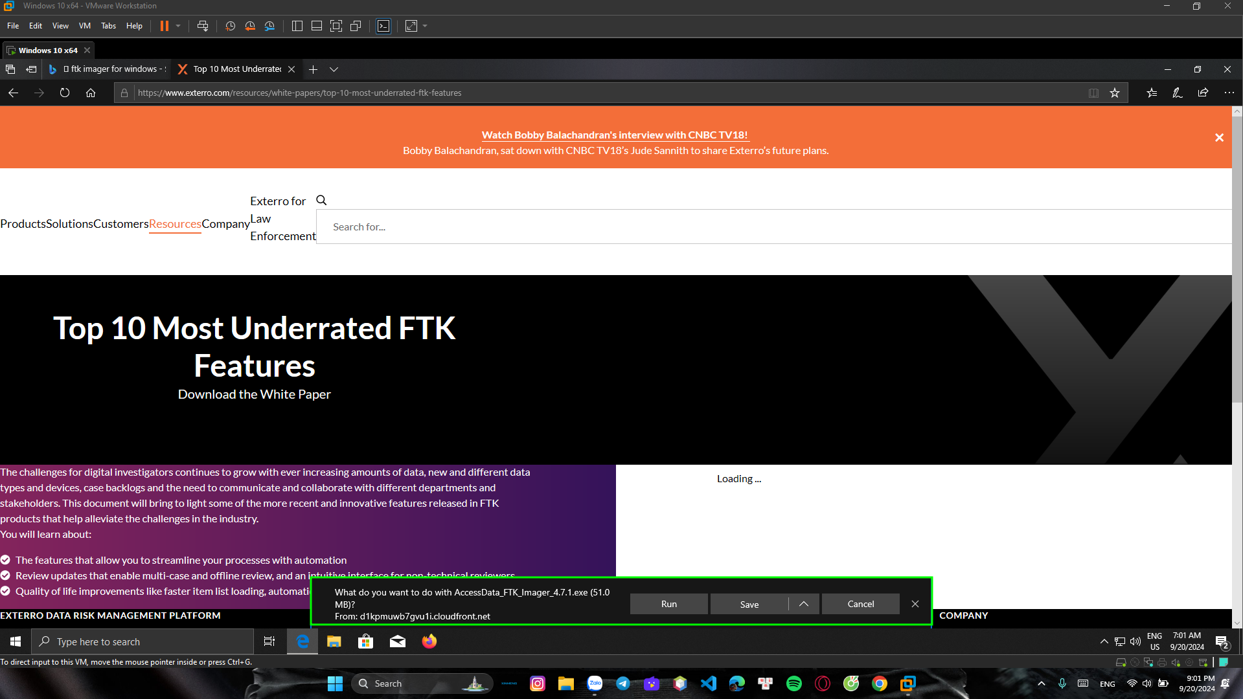

**Step 2.**

* Plug in a Flash Drive to your computer : you can copy come files to the USB.
* Verify your PC can read the USB drive

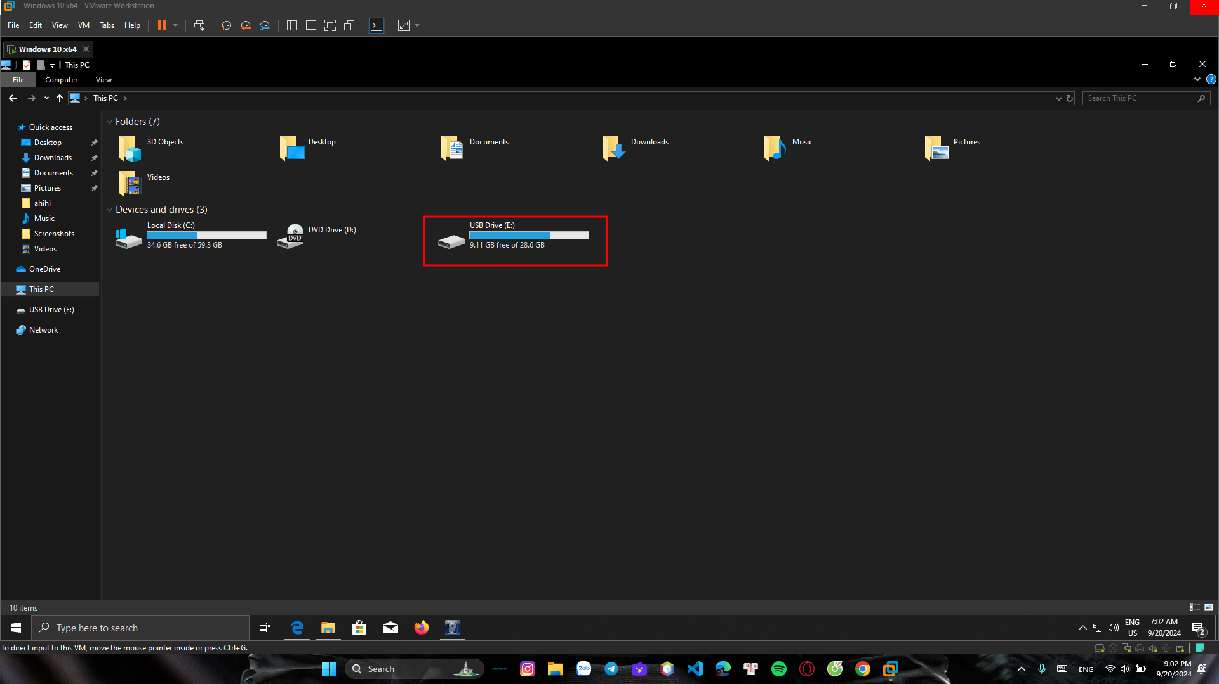

**Step 3.**

* Acquiring a USB using FTK

